**Redirections of code flow**

Welcome Screen (jsp) -> QaController <--> QaViews(Authentication)(fetch examlist)

ExamList(jsp)

FetchQA

**Screenshots:**

**Welcome Screen (jsp)**

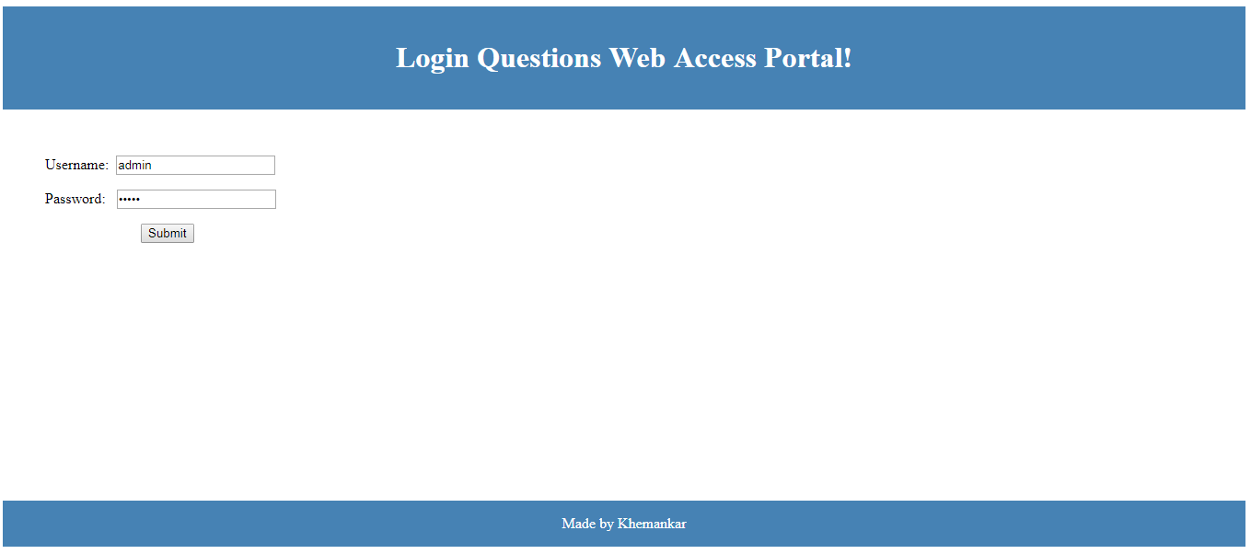

**ExamList(jsp)**

Select **BANK_PO** in the list.

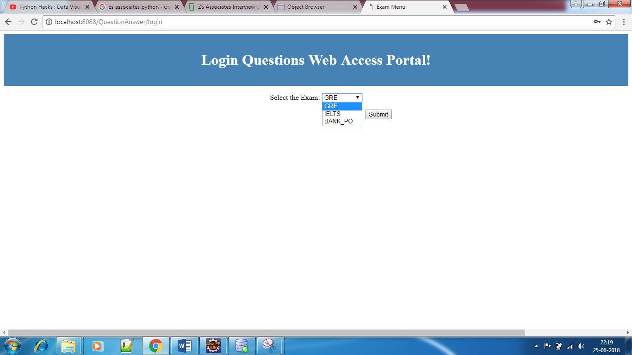

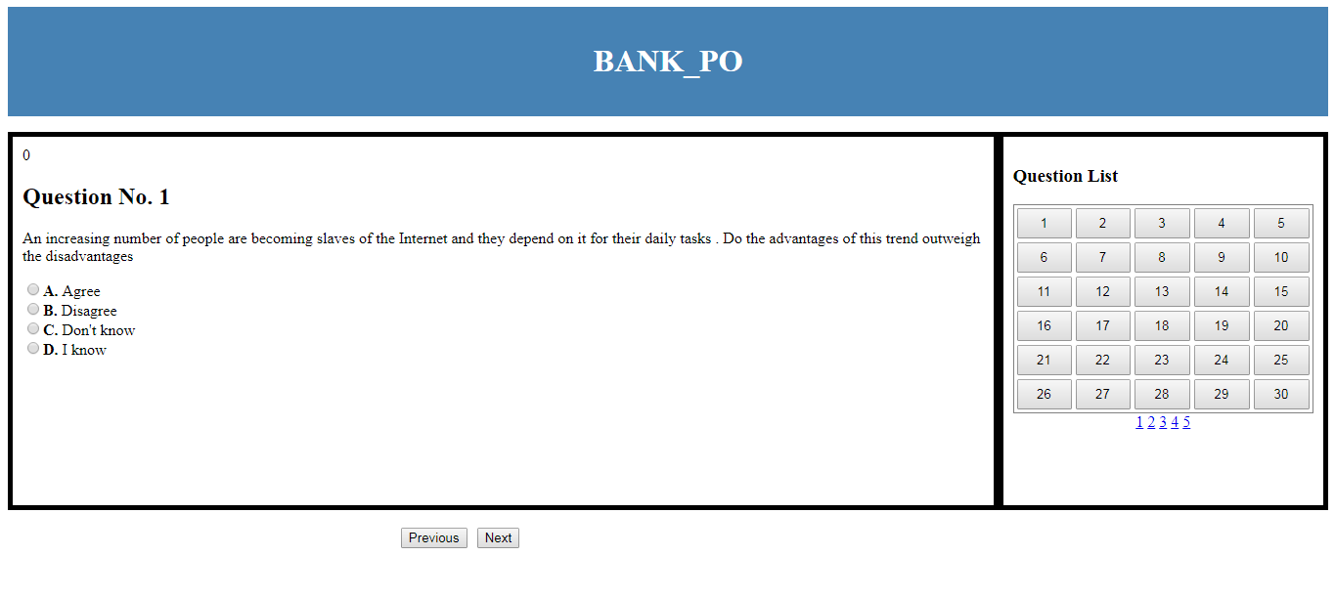

**QuestionList(jsp)**

**Requirements:**

1. No. of question for any type of exam should be from DB. Like GRE should have 60 questions, where BANK_PO has 30 questions.
2. Don’t want multiple jsp-servlet-DB control passing while fetching questions. Meaning, it should fetch the questions list at once.
3. It should be rugged enough that even if the window closes accidently, it should start the session from previous state.
4. Need a timer taken by a candidate on per question.
5. Need counter timer for the entire exam.
6. At the end of the counter-timer, it should send all the data to the servlet, which will save all the questions with its corresponding answer.

**Database**

CREATE table "USERTABLE" (

"USERNAME" VARCHAR2(255),

"PASS" VARCHAR2(255)

“EXAM” VARCHAR2(255)

)

CREATE table "EXAMLIST" (

"S_NO" NUMBER(3,0),

"EXAM" VARCHAR2(255)

)

Insert into assa_user.USERTABLE (USERNAME,PASS,EXAM) values (“admin”,”admin”,”1,2,3”);

Insert into assa_user. EXAMLIST (S_NO, EXAM) values (“1”,”GRE”);

Insert into assa_user. EXAMLIST (S_NO, EXAM) values (“2”,”IELTS”);

Insert into assa_user. EXAMLIST (S_NO, EXAM) values (“3”,”BANK_PO”);

CREATE table "QALIST" (

"EXAMLIST" VARCHAR2(255),

"TYPE" VARCHAR2(255),

"QUESTION" VARCHAR2(255)

)

Insert into assa_user. QALIST (EXAMLIST,TYPE, QUESTION) values (“BANK_PO”,” VERBAL”,”   
An increasing number of people are becoming slaves of the Internet and they depend on it for their daily tasks . Do the advantages of this trend outweigh the disadvantages? Agree;Disagree;Don't know;I know ”);

Insert into assa_user. QALIST (EXAMLIST,TYPE, QUESTION) values (“BANK_PO”,” VERBAL”,” Vincent has a paper route. Each morning, he delivers 37 newspapers to customers in his neighborhood. It takes Vincent 50 minutes to deliver all the papers. If Vincent is sick or has other plans, his friend Thomas, who lives on the same street, will sometimes deliver the papers for him? Are you Indianjjjjjjjjjjjjjjjjjjjjjjjjjjjj; Are you there;Are you dffsfdsjjjjjjjjjjjjjjjjjjjjjjjf; I am here ”);

CREATE table "USERTABLE" (

"USERNAME" VARCHAR2(255),

"PASS" VARCHAR2(255),

"EXAM" VARCHAR2(255)

)